

Guardrail End Treatment Maintenance Application

Standard Operating Procedure (SOP)

TPP, MNT, DES

**Table of Contents**

Purpose 2

Site Navigation 2

Legend: 3

Basemap Gallery: 3

Editing Window: 4

Editing Existing Points 5

Adding a Point 6

Deleting a Point 8

Using Street View 9

Contact Info 10

# Purpose

Ongoing maintenance of your end treatment inventory can be accomplished using the Guardrail End Treatment (GET) web application. Existing end treatment location and attribute information can be edited or deleted, and newly installed end treatments can be added using the web application.

# Site Navigation

1. Links
2. Legend
3. Basemap Gallery
4. Editing Window
5. Zoom and Full Extent

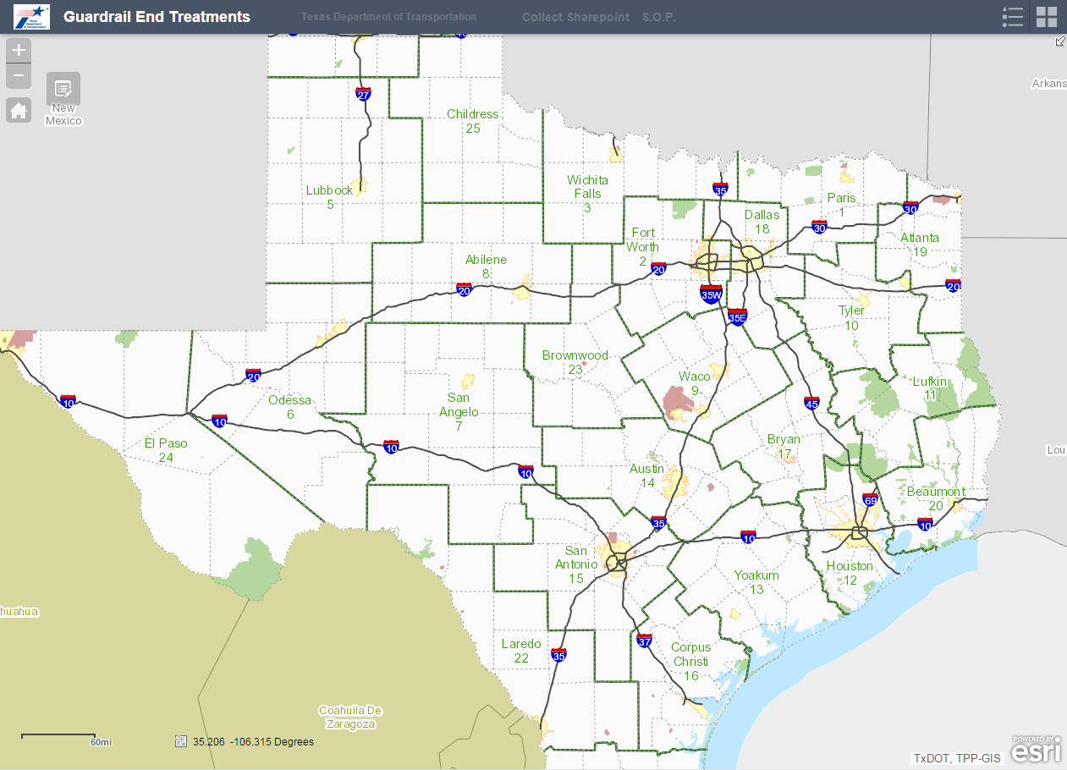

Note: you must zoom in to approximately the county level before points will appear (due to the large number of points).

**5**

**3**

**2**

**4**

**1**

Legend: Zoom in to see the guardrail end treatment points. **Note:** The legend will be blank until zoomed in far enough to see the points.

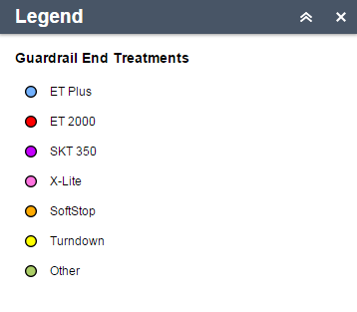

Basemap Gallery: Choose between different basemaps, including aerial imagery, topographic basemaps, and the TxDOT Statewide Planning Map basemap. Click on a basemap in the Gallery window to change background images. The various basemaps provide a variety of useful information when navigating the map.

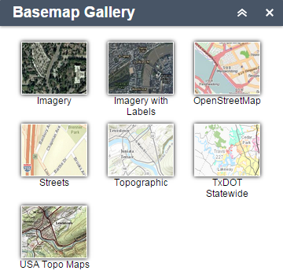

Editing Window: Open this window to edit GET points or access the Google Street View. Click a Guardrail End Treatment icon to add a new GET point to the map. The icon will remain shaded while active. Click the icon again to unselect it.

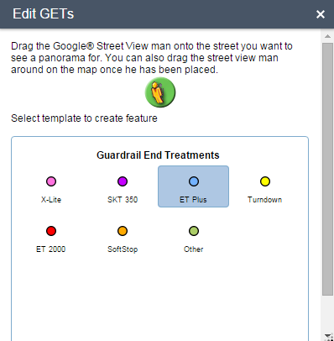

# Editing Existing Points

1. Click on the Edit GETs button to begin editing.  
    
2. With the Edit GETs dialog open, click on a point to edit its attribute information. A dialog box will open, as shown below. Click in any of the available text boxes to edit that attribute. The OBJECTID, Latitude, and Longitude fields are not editable.  
   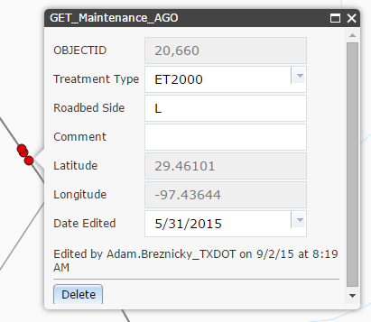
3. To relocate a point, simply select it and drag to a new location.

# Adding a Point

1. Click on the Edit GETs button to begin editing.  
    
2. With the Edit GETs dialog open, select the desired end treatment type. Your mouse will display a small tool tip with the message “Click to add a point (Press and hold CTRL if you would like to enable snapping).” Click in the desired location to place a point.

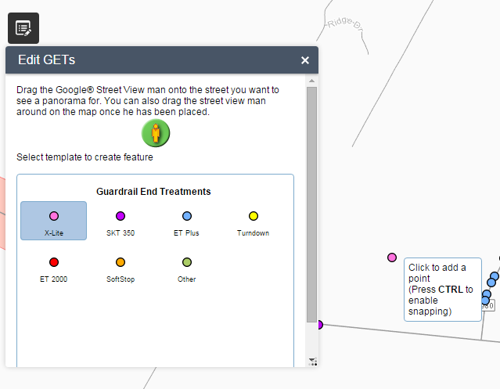

1. After adding the point, the attribute dialog box will open and you may enter your attributes. Click the X in the top right corner to save and close the dialog box.  
   
2. You may also click the Delete at the bottom, if you decide not to keep the point.

# Deleting a Point

1. Click on the Edit GETs button to begin editing.  
    
2. With the Edit GETs dialog open, click on a point to open the attribute dialog box.
3. Click the Delete button in the lower left corner.  
   

# Using Street View

1. Click on the Edit GETs button to begin editing.  
    
2. With the Edit GETs dialog open, select the Street View peg man and drag him to a road. A Google Street View window will open. The window will remain open until you close it. You can resize the window and position it on a second screen (if you have one).

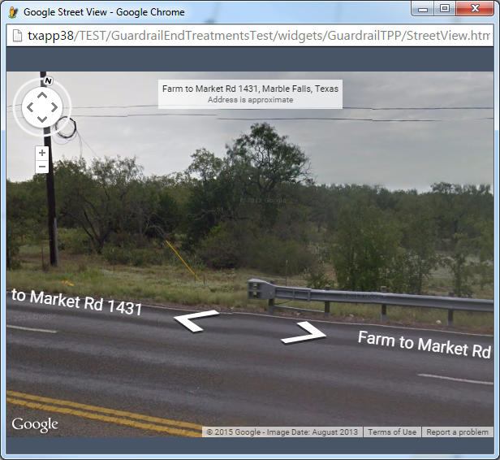

1. Pan around in the street view window to search for guardrail end treatment locations.

# Contact Info

For technical issues please contact TP&P.

[TPP-GIS@txdot.gov](mailto:TPP-GIS@txdot.gov)

(512) 486-5052